Project Design Phase-II
Data Flow Diagram & User Stories

Date | 19 February 2026
Team ID | LTVIP2026TMIDS82248
Project Name | DocSpot: Seamless Appointment Booking for Health
Maximum Marks | 4 Marks

Data Flow Diagrams:
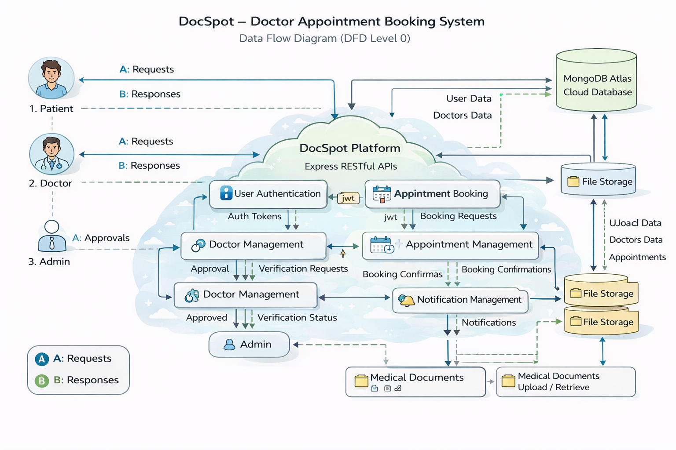
User Stories
User Type | Functional Requirement (Epic) | User Story Number | User Story / Task | Acceptance criteria | Priority | Release
Customer (Web User) | Registration | USN-1 | As a user, I can register using email and password to access the platform. | Account created successfully and redirected to dashboard. | High | Sprint-1
Customer (Web User) | Authentication | USN-2 | As a user, I can log in securely using my credentials. | Successful login generates JWT and opens user dashboard. | High | Sprint-1
Customer (Web User) | Doctor Listing | USN-3 | As a user, I can view available doctors filtered by specialization and availability. | Doctor list loads from database with approved doctors only. | High | Sprint-1
Customer (Web User) | Appointment Booking | USN-4 | As a patient, I can book appointment by selecting date & time slot. | Appointment created with status “Pending” | High | Sprint-2
Customer (Web User) | Document Upload | USN-5 | As a user, I can upload medical documents while booking an appointment. | File uploads successfully and stored in local storage. | Medium | Sprint-2
Doctor | Appointment Management | USN-6 | As a doctor, I can approve or reject appointment requests. | Appointment status updates to Scheduled or Rejected. | High | Sprint-3
Administrator | Doctor Approval | USN-7 | As an admin, I can approve or reject doctor registration requests. | Approved doctors become visible to patients. | High | Sprint-3
Administrator | Platform Management | USN- 8 | As an admin, I can monitor users, doctors, and appointments. | Admin dashboard displays system data correctly. | High | Sprint-3
Customer Care Executive | Notifications | USN-9 | As a user, I receive appointment status notifications. | Notifications stored in DB with unread/read tracking. | Medium | Sprint-4
Customer (Web User) | Appointment History | USN-10 | As a user, I can view my past and upcoming appointments. | Appointment history visible in dashboard. | Medium | Sprint-5
Doctor | Schedule Management | USN- 11 | As a doctor, I can view my appointment schedule by time slots. | Doctor dashboard shows booked slots correctly. | Medium | Sprint-4
Customer (Web User) | Appointment Cancellation | USN- 12 | As a user, I can cancel my booked appointment. | Appointment status updated and doctor notified. | Medium | Sprint-5

